1. 
2. 
3. 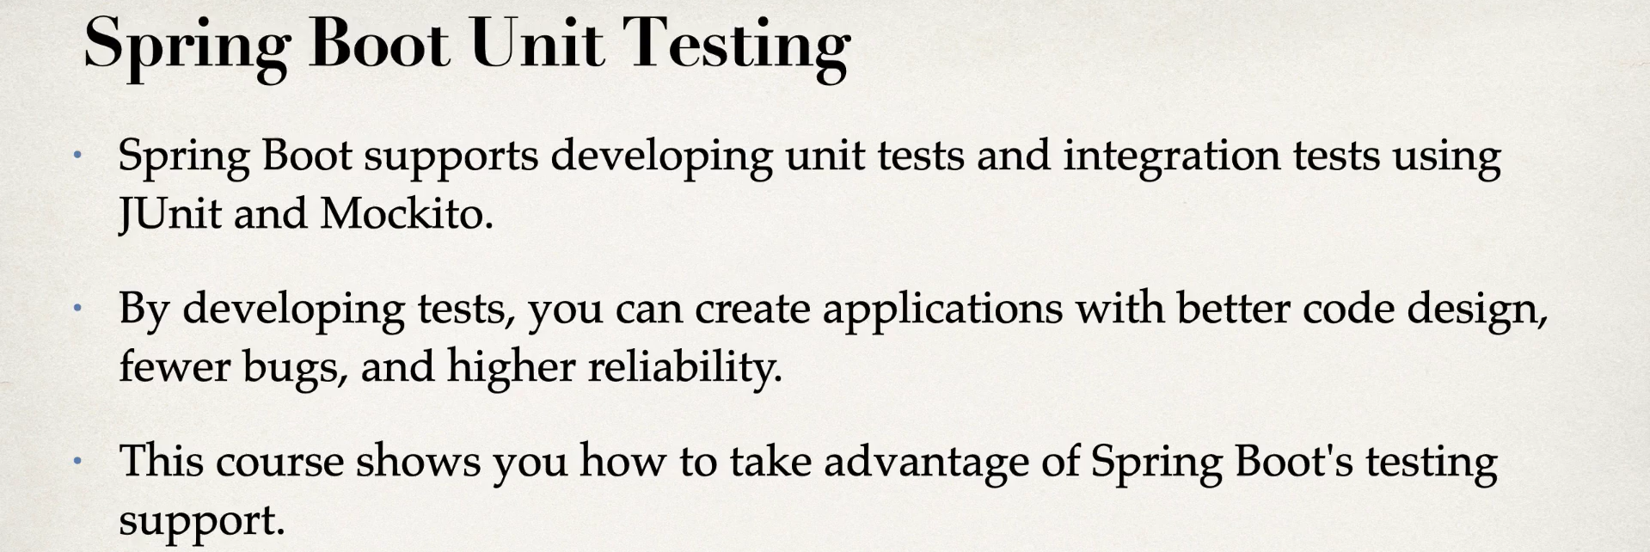
4. Let’s look at our Course Road Map.
5. 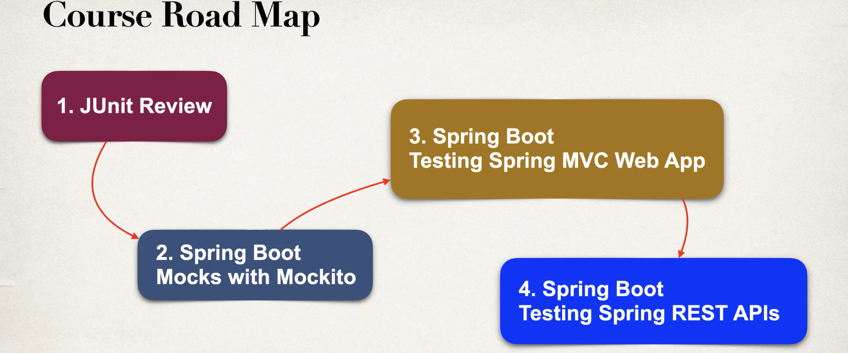
6. 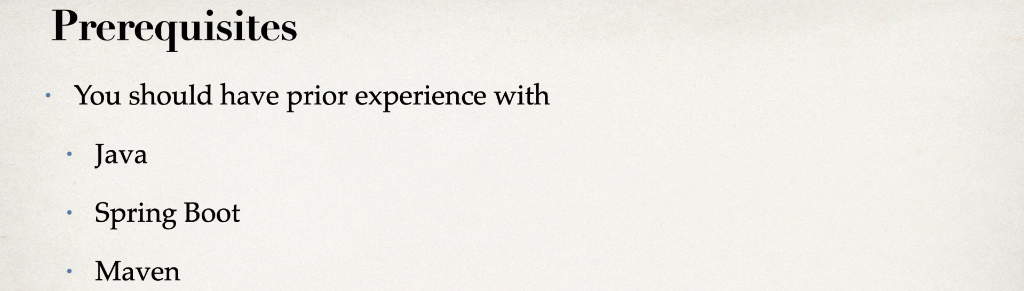
7. 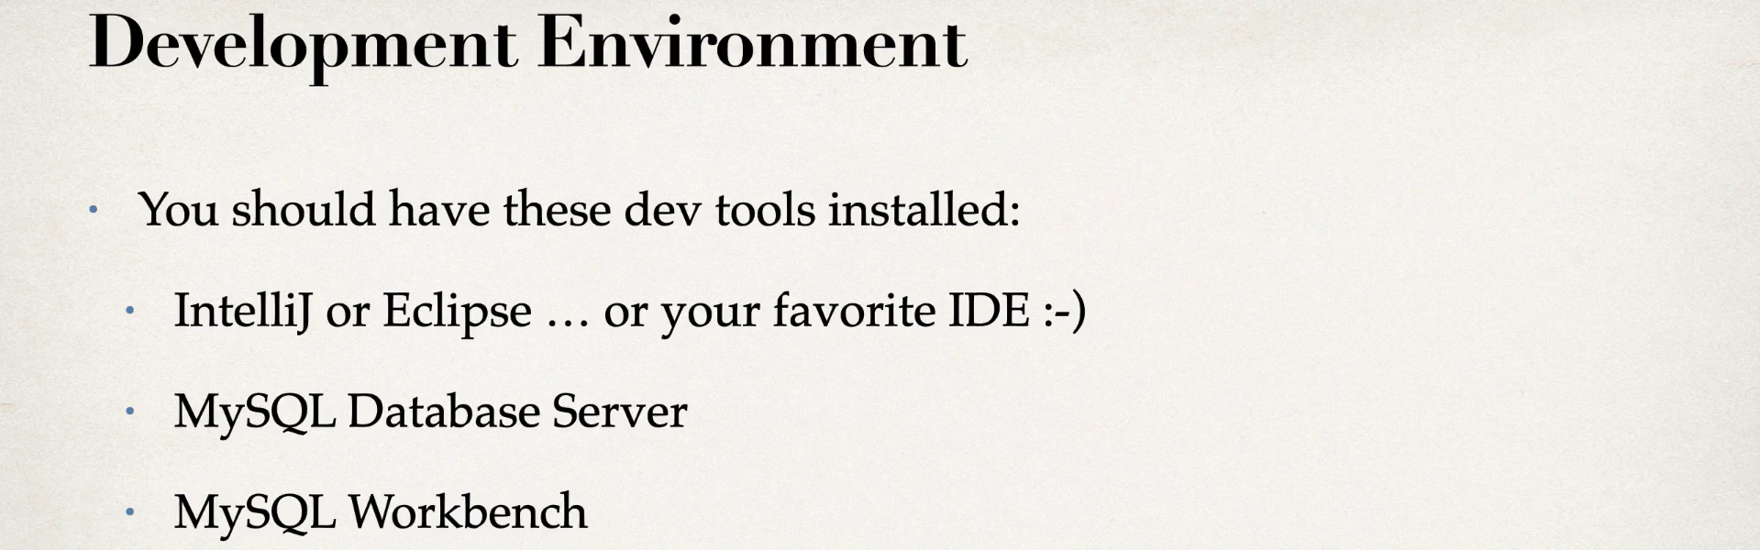
8. 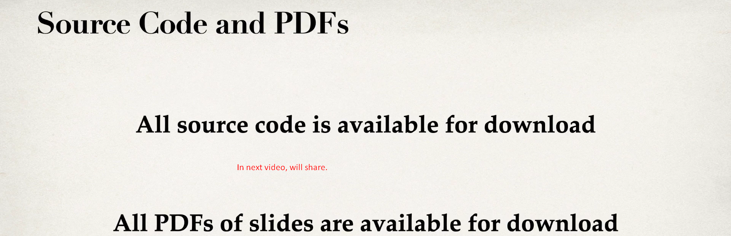
9. 